Physics 20 Lessons 1 to 32 Review

Kinematics

1. A car travels 150.0 km in 3.0 h. What is its average speed? (50 km/h)

2. A runner with a speed of 5.5 m/s covers a distance of 85.0 m during a practice race. How long does she take? (15 s)

3. A vehicle travels 1.5 × 102 m in 7.5 s, then 2.0 × 102 m in a further 5.0 s. What is the vehicle’s speed during each part of the journey? What is its average speed?

(20 m/s, 40 m/s, 28 m/s)

4. An electron accelerates in a straight line from 4.0 × 106 m/s to 6.5 × 106 m/s in 1.4 × 10-2 s. What is its acceleration? (1.8 × 108 m/s2)

5. A bus was seen to move with a velocity of 15.0 km/h north. 3.0 minutes later it was moving with a velocity of 10.0 km/h south. What was its average acceleration?

(8.3 km/h/min south))

6. A jet car starting at 8.0 m/s accelerates uniformly at 4.0 m/s2 for 7.5 s. Find the car's final speed and the distance it covers. (38 m/s, 1.7 × 102 m)

7. A Japanese bullet train is observed to move through 1.5 × 102 m in 5.0 s as it accelerates at 8.0 m/s2. Find the train's initial and final speeds. (10 m/s, 50 m/s)

8. A car accelerated from rest at a rate of 2.5 m/s2. How long will it take to reach a speed of 15.0 m/s? (6.0 s)

9. Find the acceleration of a crate originally at rest, if it covers 34 m in 7.2 s. (1.3 m/s2)

10. A motorcycle initially travelling at 15.0 m/s comes to rest in 5.0 s. What is its deceleration and how far does it travel during deceleration? (-3.0 m/s2, 38 m)

11. A plane taking off on the runway of an airport accelerates at 3.5 m/s2 from rest for 7.5 s. Determine:

i. the plane's speed after 7.5 s. (26 m/s)

ii. its average speed. (13 m/s)

iii. the distance it travelled in 7.5 s. (98 m)

12. If a box takes 15.0 s to fall from a cliff top to the ground below, how tall is the cliff? (1.1 × 103 m)

13. If a ball is dropped from rest, find its speed after 16.0 s. (157 m/s)

14. How long would a brick take to fall from a height of 78 m on the moon where the gravitational acceleration is 1.7 m/s2? (9.6 s)

15. A boy threw a metal ball straight down from an apartment block window with an initial speed of 14.0 m/s. What was its speed just before it struck the ground 4.2 s later? (55 m/s)

16. An arrow is fired up into the air with an initial speed of 95.0 m/s.

i. How long does it take to reach maximum height? (9.68 s)

ii. How high does it rise? (460 m)

iii. How long does it take to return to the ground? (19.4 s)

17. If a projectile is fired vertically into the air and attains a maximum height of 1.0 × 103 m, what is its speed of projection? How long will it take to rise? (140 m/s, 14.2 s)

## Kinematics—graphing

1. Sketch a displacement—time graph showing

a) constant positive velocity.

b) zero velocity.

c) constant negative velocity.

d) constant positive acceleration from rest.

e) constant negative acceleration from rest.

f) the motion of an object thrown upwards with a high initial velocity to the time where the object comes back to the ground.

2. Sketch the velocity—time graph showing

a) constant positive velocity.

b) constant negative velocity.

c) constant positive acceleration from rest.

d) constant negative acceleration from rest.

e) the motion described in part f) of question 1. What is the slope of this graph on Earth?

3. What physical quantity is represented by

a) the slope of a position-time graph?

b) the slope of a velocity-time graph?

c) the area under a velocity-time graph?

d) the area under an acceleration-time graph?

## Vectors

1. Which of the following quantities are vectors?

distance time velocity temperature

volume speed displacement pressure

force energy density acceleration

intensity area

2. A truck travelled 30. 0 km [N] then 40.0 km [E]. What was the car's final displacement from its starting position? (50.0 km at 53.0° east of north)

3. A motor cycle was ridden 30. 0 km [WJ and then 40.0 km [S]. It was then driven 60.0 km [El. Find its resultant displacement. (50.0 km at 53° south of east)

4. A rower intends to row his raft at its top speed of 1.5 m/s from the south bank of a river to a point directly opposite on the north bank. He fails to recognise the river current which pulls a Jog west at 0.50 m/s, What is the raft's resultant velocity with respect to the bank? (1.6 m/s at 18° west of north)

5. A 0.50 km wide east-west river has a water current of 1.2 m/s. A small boat leaves the north bank with an intended velocity of 1.8 m/s [S].

I. What is the velocity of the boat relative to the river? (1.8 m/s south)

II. What is the boat's velocity relative to the bank? (2.2 m/s at 34° west of south)

III. How long will the boat take to cross the river? (2.8 × 102 s)

IV. How far downstream from its intended arrival point will it touch the opposite bank? (3.3 × 102m)

6. A pilot intended to fly his plane with a velocity of 4.0 × 102 km/h [N] relative to the ground. He was unaware of the strong easterly wind that blew with a ground speed of 1.0 × 102 km/h. What is the plane's actual velocity relative to the ground. (4.1 × 102 km/h at 14° west of north)

7. Three forces act at a single point. Two of the forces are 39 N Southwest and 45 N north. What is the value of the third force that creates equilibrium? (7.33N)

## Projectiles

1. A projectile is fired horizontally from the top of a cliff with an initial speed of 3.0 × 102 m/s and strikes the ground below after 9.4 s. How high is the cliff? What is the projectile's range? (4.3x102 m, 2.8x103 m)

2. Santa Claus entered the North Pole Annual Elf Throwing Competition. He fired his elf with a horizontal speed of 25 m/s from the top of an iceberg of height 110 m. What was the elf's range and time of flight? (1.2 × 102 m)

3. A steeplechase runner must jump from the top of a 2.0 m high hillock and dear a water-filled ditch below which Is 3.0 m wide. If she jumps off the fence horizontally, at what speed must she leave the fence? (4.7m/s)

## Newton's laws of motion

1. An object is acted upon by an applied force of 10.0 N against a frictional force of 2.0 N. Calculate the net force on it. (8.0 N)

2. A scuba diver pushes herself through the water with a net force of 19.0 N. If her applied force is 26.0 N, find the frictional force of the water on her. (7.00 N)

3. If the coefficient of friction of a horizontal surface is 0.30 and an object of mass 4.9 kg moves on it at a steady speed. What is the frictional force on it? (14 N)

4. If there is a resistive force of 15.0 N on an object when a 25.0 N force is applied. Find the net force on the object. (10.0 N)

5. Calculate the acceleration of a 3.9 kg skateboard acted on by a net force of 4.0 N.

(1.0 m/s2)

6. What is the acceleration of a 3.2 × 102 kg block subject to an unbalanced force of 94 N? (0.29 m/s2)

7. What is the unbalanced force required to cause an acceleration of 8.2 m/s2 in a sack of flour of mass 5.1 kg? (42 N)

8. A crate of mass 25.0 kg is moved along a level floor by an applied force of 1.5 × 102 N against a frictional force of 50.0 N. Determine the acceleration of the crate. (4.0 m/s2)

9. If a trolley of mass 5.00 kg is accelerated at 3.50 m/s2 against a frictional force of 10.0 N, determine the applied force. (27.5 N)

10. A bus of mass 4.5 × 104 kg is subjected to a force of 3.4 × 104 N and accelerates at a rate of 0.67 m/s2. Calculate the resistive force on the bus. (3.9 × 103 N)

11. A ball is seen to accelerate from 2.5 m/s to 6.0 m/s in 1.1 s. If its mass is 0.60 kg, find the average net force on it. (1.9 N)

12. A toy truck of mass 0.25 kg is pushed from rest by a force of 5.0 N against a frictional force of 3.0 N for a distance of 3.0 m. What is the final speed of the truck? How long does the motion take? (48 m/s, 0.87 s)

13. Two wooden blocks A and B have respective masses of 3.0 kg and 4.0 kg and are connected with an inextensible cord. If the blocks are placed on a horizontal frictionless surface and a force of 8.0 N is applied to A, find the tension in the connecting cord. (4.6 N)

14. A plane of mass 6.0 × 1 05 kg travelling at 1.5 × 102 m/s is accelerated to 2.0 × 102 m/s in 10.0 s. If there is air resistance on the plane equal to 1.0 × 106 N, determine

i. the acceleration of the plane (5.0 m/s2)

ii. the net force on the plane (3.0 × 106 N)

iii. the applied force on the plane (4.0 × 106 N)

15. A man of mass 60.0 kg stands in an elevator. Find the force of the elevator on his feet when

i. it moves upward at a steady 2.0 m/s (5.9 × 102 N)

ii. it moves downwards at a constant rate of 1.5 m/s (5.9 × 102 N)

iii. it moves upwards with a uniform acceleration of 2.0 m/s2. (7.1 × 102 N)

iv. it moves downwards with a constant acceleration of 2.0 m/s2 (4.7 × 102 N)

16. Newton's Second Law of Motion can be stated in the equation . This law is one of three very important laws of motion. His first law, which was known to Galileo, dealt with objects that move with uniform motion.

i. What is uniform motion?

ii. What is the acceleration of a body moving with uniform motion?

iii. What is the net force on a body moving with uniform motion?

iv. What do you think Newton said about the forces on a body that moves with uniform motion?

v. State how Newton phrased his First Law of Motion.

17. Two horses are pulling a barge along a canal. Each horse exerts a force of 1.2 × 103 N at 30° to the forward direction of motion but on opposite sides of the canal. If the barge glides in the water at a steady speed, find the water resistance on the barge. (2.1 × 103 N)

18. An apple rests on a table and its weight is defined as the action force. What is the reaction force?

## Circular motion and Gravitation

1 . What is the equation for the speed of an object moving around a circle of radius (r) and taking time (T)?

2. Define period and frequency for uniform circular motion.

3. If an object moves at a constant speed in a circle, it is still accelerating. Why?

4. What is the direction of the velocity vector in uniform circular motion?

5. What is the direction of the acceleration (and force) vectors in uniform circular motion?

6. A car travels around 8 curved path that ha 8 radius of 195 m at a constant speed of 22 m/s. What is the centripetal acceleration of the car? (2.5 m/s2)

7. An amusement park ride has 8 radius of 2.5 m. If the time of one revolution of a rider is 0.75 s, what is the speed of the rider? (21 m/s)

8. Calculate the (a) speed and (b) acceleration of a point on the circumference of a 33 1/3 phonograph record (Remember those? Probably not!). The diameter of the record is 30.0 cm. (Note that 33 1/3 is the frequency of the record in rpm.) (0.52 m/s, 1.83 m/s2)

9. An athlete whirls a 3.8 kg shot-put in a horizontal circle with a radius of 0.90 m. If the period of rotation is 0.30 s.

a) What is the speed of the shot-put when released? (19 m/s)

b) What is the centripetal force acting on the shot-put while it is rotated? (1500 N)

c) How far would the shot-put travel if it is released 1.2 m above the ground?

(9.3 m)

10. A 2700 kg satellite orbits the Earth at a distance of 18000 km from the Earth's centre at a speed of 4700 m/s. What is the force acting on the satellite? (3300 N)

11. A 2.2 kg object is whirled in a vertical circle whose radius is 1.0 m. If the time for one revolution is 0.97 s, what is the tension in the string (assuming uniform circular motion):

a) at the top of the circle? (70.7 N)

b) at the bottom of the circle? (114 N)

12. A 2.0 kg mass is swung in a vertical circle of radius 1.2 m using a cord that will break if it is subjected to a force greater than 252 N. What is the maximum speed that this mass can travel as it passes through the bottom of the circle? (12 m/s)

13. How fast can a 1200 kg car round an unbanked curve of radius 62 m if the coefficient of friction between the tires and the road is 0.44? (16 m/s)

14. A 925 kg car rounds an unbanked curve at a speed of 25 m/s. If the radius of the curve is 72 m, what is the minimum coefficient of friction between the tires and the road so that the car does not skid? (0.88)

15. What are Kepler's Laws?

16. What are the two ways in which the weight of an object can be calculated?

17. What is another name for acceleration due to gravity and how can it be calculated?

18. Given that the mass of Venus is 4.83 × 1024 kg and the mass of Earth Is 5.98 × 1024 kg, and that the orbital radius for Venus is 1.08 × 1011 m and for Earth is 1.49 × 1011 m:

a. Determine the MAXIMUM force of gravitational attraction between Venus and Earth. (1.15 × 1018 N)

b. If you weigh 445 N on Earth, what will you weigh on Venus? The radius of Venus if

6.31 × 106m. (367 N)

c. If you were placed on a line between Earth and Venus, at what point measured from Earth would you experience equal gravitational force from each planet?

(2.16 × 1010 m)

19. If you weigh 890 N on Earth, what is the gravitational pull at a distance of 19320 km ABOVE THE SURFACE of the Earth? (55.6 N)

20. If you weigh 667 .5 N on Earth, what will you weigh on a planet that has 5 times the mass of Earth but only twice the diameter of the Earth? (834 N)

21. What is the gravitational field strength on the surface of the moon if the radius of the moon is 1.764 × 106 m and the mass of the moon is 7.34 × 1022 kg? (1.62 N/kg)

22. What is the gravitational field strength 1.27 × 107 m above the surface of the Earth?

(1.09 N/kg)

23. On the surface of planet X an object has a weight of 63.5 N and a mass of 22.5 kg. What is the gravitational field strength on the surface of planet X? (2.82 N/kg)

24. At what distance above the Earth's surface is the gravitational field strength equal to

7.33 N/kg? (1.01 × 106 m)

25. What is the speed of an artificial satellite of mass 625 kg which is placed in an orbit

1.00 × 106m above the surface of a planet with a mass of 3.18 × 1023 kg and a radius of 2.43 × 106m? (2.49 × 103 m/s)

26. An artificial satellite with a mass of 572 kg Is placed into a circular orbit around the Earth which has a mass of 5.98 × 1024 kg. If the radius of the orbit Is 1.2 × 107 m how long will it take to make one revolution? (1.3 × 104 s)

27. What is meant by the term geo-synchronous?

## Simple Harmonic Motion and Waves

## Fill in the blank

1. _______________ waves require a material medium for energy transfer.

2. A(n) _______________ wave causes the particles of the medium to vibrate in a direction perpendicular to the direction in which the wave is travelling.

3. _______________ waves need no medium for travel.

4. A(n) _______________ is a single disturbance travelling through a medium.

5. The_______________ of a wave is the number of waves that pass a given point per second.

6. The _______________ of a wave is the reciprocal of its frequency.

7. The _______________ of a wave is the linear distance between any two corresponding points on consecutive waves.

8. The energy content of a mechanical wave is characterised by its _______________.

9. _______________ is the process involved when two waves meet and super- impose their amplitudes.

10. The _______________ of a mechanical wave depends on the medium.

11. When waves pass from one medium into another, their _______________ remains unchanged.

12. A(n) _______________ wave is produced when a wave train moving in one direction meets an identical wave train moving in the opposite direction.

13. Two pulses with identical shapes but opposite displacements move toward each other in a medium. The point in the medium that is never displaced is a(n) _______________.

14. _______________ is the direction change of waves at the boundary between different media.

15. _______________ is the bending of a wave around an obstacle.

16. _______________ are undisturbed areas that are formed when two sets of waves interact with one another.

17. The_______________ is a line perpendicular to a barrier at the point where an incident ray strikes the barrier .

18. When a wave is reflected from a barrier, the angle of _______________ equals the angle of reflection.

## Multiple choice

1. Waves provide a means of transferring

a. matter.

b. particles.

c. liquids.

d. energy.

2. A 10-Hz wave has a 2-cm wavelength. The velocity of this wave is

a. 5 cm/s.

b. 8 cm/s.

c. 12 cm/s.

d. 20 cm/s.

3. A sound wave travels from A to B. In which direction do the particles of the medium vibrate?

A

B

a.

b.

4. Which of the mechanical waves represented below has the greatest energy?

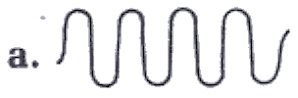 b. 

5. If an incident wave makes a 200 angle with a barrier, the reflected wave makes a ____________ angle with a perpendicular drawn to the barrier.

a. 10°

b. 20°

c. 50°

d. 70°

6. A is an incident ray. Which is the corresponding reflected ray?

a.

b.

c.

d.

A

7. If the amplitude of the reflected pulse is ___________ when a wave passes from one medium to another, most of the energy has been transmitted.

a. inverted

b. erect

c. large

d. small

8. Which two points are in phase?

B

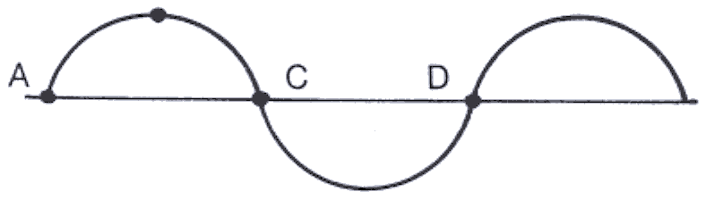

a. A and C

b. B and C

c. A and D

d. B and D

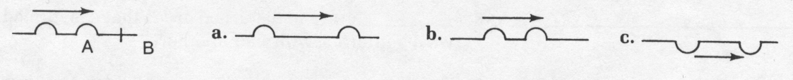9. Pulses are going from medium A to medium B as shown. The speed of the waves in B is greater. Which diagram best describes the pulses in B?

10. Which diagram below will lead to destructive interference?



11. When waves refract, the waves do not change

a. speed.

b. frequency.

c. wavelength.

d. direction.

## Questions

1. A microwave has a wavelength of 3 cm and a speed of 3 × 108 m/s. Calculate the frequency. (1.0 × 1010 Hz)

2. Two boats are anchored 4 m apart. They bob up and down every 3 s, but when one is up, the other is down. There are never any wave crests between the boats. Calculate the velocity of the waves. (2.7 m/s)

3. An incident ray strikes a barrier in the diagram below. Draw the reflected ray on the diagram

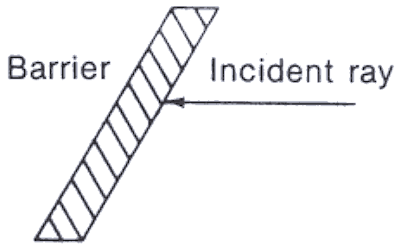

4. Using the principle of superposition, sketch the actual shapes of the three sets of pulses in the diagram below. The pulses are shown without interference.

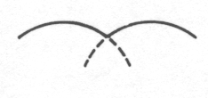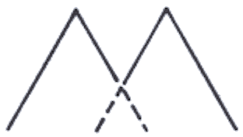 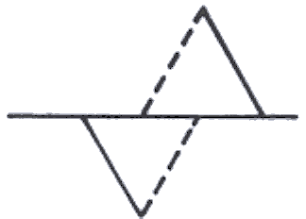

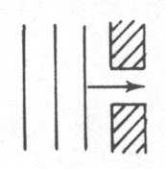5. Sketch the shape of the waves in the diagram below after they have passed through the barrier .

6. Sketch the reflected waves in the diagram at the right.

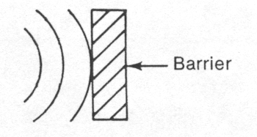7. Ocean waves normally form breakers only as they approach the shoreline. Why?

8. A 4.0 m long boat is anchored facing into the waves. The waves have a velocity of 5.0 m/s. It is possible for exactly three wave crests to fit under the boat at one time.

a. Calculate the frequency of the waves. (2.5 Hz)

b. The boat lifts anchor and moves into the waves at 6.0 m/s relative to the shore. What is the speed of the waves relative to the boat? (11 m/s)

c. Calculate the frequency of the waves relative to the moving boat. (5.5 Hz)

9. A box containing BB's is suspended from a vertical spring with spring constant k. A long horizontal spring is attached to the side of the container as shown. The container is pulled down and released. On each oscillation, a BB is released from the container when it is in its lowest position. Discuss the waves produced in the horizontal spring as the container oscillates.

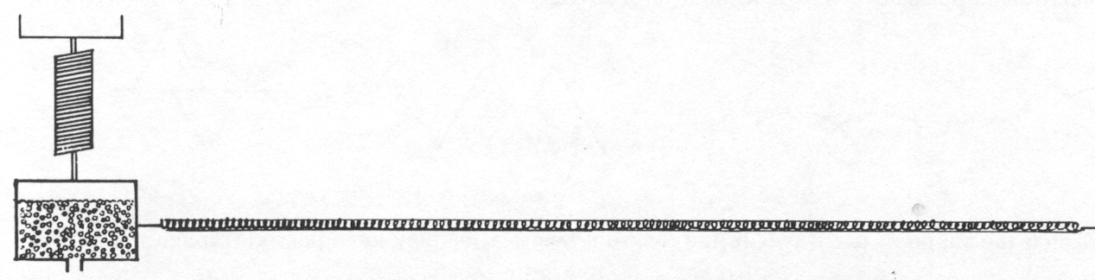

10. The speed of an ocean wave on the coast is 42 m/s and the wavelength is 1.5 m. What is the frequency with which the wave hits the beach? (28 Hz)

11. If the speed of sound in air is 340 m/s and the wavelength of a sound is 5.0 m, what is the frequency of the sound? What is the frequency of this sound as it moves into water? (68 Hz, same)

12. What is the wavelength of a sound emitted by a tuning fork of frequency 440 vibrations per second? The speed of sound is 332 m/s at 0.0°C and increases 0.60 m/s for each degree temperature rise. The tuning fork is at 32°C. (0.80 m)

13. Radio waves travel at the speed of light, 3.0 × 108 m/s. What is the wavelength of a radio wave from an AM station broadcasting at a frequency of 750 kHz? Find the frequency. (400 Hz)

14. A standing wave in a clothesline has 4 nodes and 3 antinodes. The clothesline is 12 m long and is vibrating at 0.50 vibrations per second. What is the speed of the wave? (4.0 m/s)

15. A wave travels from one medium to another, and the wavelength decreases. What happens to the velocity and the frequency?

16. Starting with the wave shown, sketch the following.

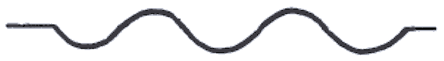

a. a wave with twice the amplitude

b. a wave with twice the frequency

c. a wave with twice the wavelength

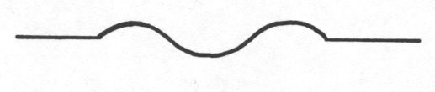17. If a wave on a drum looks like the diagram. sketch how the wave would look if the drum were hit harder.

18. The pulse below is being reflected from a fixed end. Sketch the reflected pulse.

19. You are crossing in a crosswalk when an approaching driver blows his horn. If the true frequency of the horn is 264 Hz and the car is approaching you at a speed of 60.0 km/h, what is the apparent (or Doppler) frequency of the horn? Assume that the speed of sound in air is 340 m/s. (278 Hz)

20. An airplane is approaching at a speed of 360 km/h. If you measure the pitch of its approaching engines to be 512 Hz, what must be the actual frequency of the engines? The speed of sound in air is 345 m/s. (364 Hz)

21. An automobile is travelling toward you at a speed of 25.0 m/s. When you measure the frequency of its horn, you obtain a value of 260 Hz. If the actual frequency of the horn is known to be 240 Hz, calculate the speed of sound in air. (325 m/s)

22. As a train moves away from you, the frequency of its whistle is determined to be 475 Hz. If the actual frequency of the whistle is 500 Hz and the speed of sound in air is 350 m/s, what is the train's speed? (18.4 m/s)

23. A 5.0 kg mass hung from a spring vibrates with a frequency of 0.80 Hz. What is the spring constant? (1.3 × 102 N/m)

24. If the period of vibration for a pendulum is measured to be 2.75 s, how long is the pendulum? (1.88 m)

25. A 500 g mass is hung from a spring. The mass caused the spring to stretch by 45.0 cm. What is the spring constant for the spring? (10.9 N/m)

**Simple Harmonic Motion and Waves Answers**

|  |  |
| --- | --- |
| **Fill in the blank** | **Multiple choice** |
| 1. mechanical 2. transverse 3. light 4. pulse 5. frequency 6. period 7. wavelength 8. amplitude 9. interference 10. speed 11. frequency 12. standing 13. node 14. refraction 15. diffraction 16. nodes 17. normal 18. incidence | 1. d 2. d 3. b 4. b 5. b 6. d 7. d 8. c 9. a 10. b 11. b |

**Work, Power, Energy**

1. A man pulling a wagon exerts a force of 55 N along the handle which is set at 25o to the horizontal. If the man pulls the wagon 650 m during 5.6 minutes, what power is consumed? ( 96.4 W )

2. What is the kinetic energy of a 50 kg object that has fallen 176.4 m? (86.4 kJ)

3. What work is done in dragging a 50 kg mass 40 m across a surface at constant speed with a coefficient of friction equal to 0.85? ( 16.66 kJ )

4. An archer puts a 0.30 kg arrow to the bowstring. An average force of 201 N is exerted to draw the string back 1.3 m.

a) With what speed will the arrow leave the bow? ( 42 m/s )

b) If the arrow is shot straight up, how high does it go? ( 90 m )

5. A 28 kg child climbs the ladder to a 4.8 m high slide and after sliding down reaches a speed of 3.2 m/s at the bottom. How much work was done by friction on the child? (1.2 kJ)

6. An object is located 2 m above a table top that is 1.5 m above the floor. If the mass of the object is 40 kg;

a) What is the gravitational potential energy of the object with respect to the table top? ( 784 J )

b) What is the gravitational potential energy of the object with respect to the floor? (1372 J)

7. A 45 kg mass is dragged 50 m over a surface. If 1.0 kW of power is produced over 10 seconds, what is the coefficient of friction for the surface? (0.45)

8. A pendulum is released from a height of 0.65 m above its equilibrium position. What is the maximum speed of the pendulum bob? What is the speed of the pendulum bob when it has fallen 0.25 m from its highest point? (3.6 m/s, 2.2 m/s)

9. A 0.250 kg mass is attached to a horizontal spring with a spring constant of 20.0 N/m. The mass is pulled back and the frictionless system vibrates with simple harmonic motion. When the mass has a displacement of 12.4 cm its speed is 0.350 m/s. What is the maximum speed of the mass? (1.16 m/s)

##### Multiple Choice Review Questions

1. Quantities in physics are generally divided into

A. magnitude and scalar quantities.

B. dynamic and scalar quantities.

C. vector and scalar quantities.

D. kinematic and scalar quantities.

2. A vector is a quantity that

A. is at rest.

B. has a magnitude, a unit, and a direction.

C. explains why objects are in motion.

D. has only a magnitude and a unit.

3. A plane's velocity relative to the ground is found by adding the plane's velocity relative to the air and

A. the velocity of the plane relative to the ground.

B. the velocity of the air relative to the plane.

C. the velocity of the air relative to the ground.

D. the velocity of the ground relative to the plane.

4. A ball is being swung in a horizontal circle in the clockwise direction. Which of the following can be said about the **velocity** of the ball?

A. The velocity of the ball is increasing along the circular path.

B. The velocity of the ball is decreasing along the circular path.

C. The velocity of the ball is tangent to the circular path.

D. The velocity of the ball is perpendicular to the circular path.

5. What is the direction of acceleration of an object moving in a circular path?

A. It is tangent to the circular path.

B. It is toward the centre of the circle.

C. It is away from the centre of the circle.

D. It is equal to the arc length for small angles.

6. What does it mean for a body to be in free fall?

A. Any body falling under the influence of gravity alone.

B. Any body falling through water.

C. Any body under the influence of both horizontal and vertical forces.

D. The fall of a sky diver after his parachute opens .

7. What is the direction of the acceleration due to gravity?

A. On, the ocean floor it is down while on mountain tops it is up.

B. It is always upward, away from the Earth.

C. It is always downward toward the centre of the Earth.

D. Acceleration due to gravity is a scalar quantity and has no direction.

8. Which one of the following statements is the definition of amplitude for a pendulum?

A. The length of string from the top to the center of mass.

B. The amount of mass at the end of the string.

C. The time required for one complete cycle.

D. The maximum sideways displacement of the mass from its rest position.

9. What is a force?

A. It is a push or a pull.

B. It speeds thing up, slows them down, and sends them around corners and up hills.

C. Its is an agent that objects use to interact with one another.

D. All of the above.

10. Which of the following is true regarding gravitational field strength on Earth?

A. It is the same everywhere.

B. It is greater on mountain tops.

C. It is weaker in valleys.

D. It varies with distance from the Earth's centre.

11. Who was the first scientist to see the connection between falling objects, projectiles, and satellites in orbit?

A. Aristotle

B. Galileo

C. Newton

D. Einstein

12. How does the gravitational force between two bowling balls change as the distance between their centres is first reduced to one half and then increased to three times the original distance?

A. It first becomes four times as great and then one-ninth as great.

B. It first becomes one-fourth as great and then one-ninth as great.

C. It first becomes four times as great and then one-third as great.

D. It first becomes twice as great and then three times as great.

13. What is inertia?

A. The amount of matter in an object.

B. The force of gravity on an object.

C. The amount of force acting on each kilogram of mass.

D. The tendency of an object to resist changes in its state of motion.

14. Which of the following is a statement of Newton's First Law of Motion?

A. If no unbalanced force acts on an object, the object accelerates in the direction of the single greatest force acting on the object.

B. If no net force acts on an object, the object maintains its state of motion.

C. Acceleration varies directly with the unbalanced force.

D. For every action force, there exists a reactive force that is equal in magnitude but opposite in direction.

15. Which of the following is a statement of Newton's Second Law of Motion?

A. If an unbalanced force acts on an object, the object accelerates in the direction of the force.

B. If no net force acts on an object, the object maintains its state of motion.

C. For every action force, there exists a reactive force that is equal in magnitude but opposite in direction.

D. When no external, unbalanced force acts on an object, its velocity remains constant.

16. Which of the following is a statement of Newton's Third Law of Motion?

A. When no external, unbalanced force acts on an object, its velocity remains constant.

B. For every action force, there exists a reactive force that is equal in magnitude but opposite in direction.

C. If no net force acts on an object, the object maintains its state of motion.

D. If an unbalanced force acts on an object, the object accelerates in the direction of the force.

17. How is the acceleration of an object related to the mass and the net force?

A. Acceleration varies directly with both the unbalanced force and the mass.

B. Acceleration varies inversely with both the unbalanced force and the mass.

C. Acceleration varies directly with the unbalanced force and inversely with the mass.

D. Acceleration varies inversely with the unbalanced force and directly with the mass.

18. A transfer of energy in the form of a periodic disturbance through a medium is called a

A. wave.

B. period.

C. wavelength.

D. watt.

19. One complete vibration of a vibrating object is called a

A. series.

B. circuit.

C. cycle.

D. refraction.

20. The time required for one complete oscillation of a vibrating object is called

A. the frequency.

B. the periodic rate.

C. the period.

D. one Hertz.

21. Two objects vibrate in simple, one-dimensional motion at the same frequency and in different directions at the same time. These objects are said to be _______ with each other.

A. in phase

B. out of phase

C. out of frequency

D. out of velocity

22. Two pendulums of the same length are released from the same relative positions at the same time. One would expect them to oscillate ____________ with each other.

A. in frequency

B. in period

C. in phase

D. out of phase

23. Particles in a transverse wave vibrate

A. at right angles to the direction of travel of the wave.

B. 180° out of phase with the direction of travel of the wave.

C. at a supplementary angle to the direction of travel of the wave.

D. parallel to the direction of travel of the wave.

24. Particles in a longitudinal wave vibrate

A. at right angles to the direction of travel of the wave.

B. 180° out of phase with the direction of travel of the wave.

C. at a supplementary angle to the direction of the wave.

D. parallel to the direction of travel of the wave.

25. Waves transmitted from a faster to a slower medium will

A. decrease in wavelength.

B. increase in wavelength.

C. decrease in frequency.

D. increase in frequency and decrease in wavelength.

26. When using wave rays to describe wave reflection, the angle of incidence and the angle of reflection, are measured from

A. an imaginary line perpendicular to the reflecting surface.

B. the norma1 to a reflecting object.

C. an angle determined by the frequency of the wave.

D. Both A and B are correct.

27. Which of the following is true regarding a billiard ball and a feather dropped from the same height near the surface of the Earth.

A. The billiard ba1l and the feather will both reach terminal velocity and hit the ground at the same moment.

B. They will accelerate and hit the ground at the same moment.

C. The billiard ball will hit the ground first.

D. The feather will cling to the billiard ball and slow it down.

28. Which of the following is true regarding a billiard ball and a feather dropped from the same height near the surface of the moon. Recall that the moon does not have an atmosphere.

A. The billiard ba1l and the feather will both reach terminal ve1ocity and hit the ground at the same moment.

B. They will accelerate and hit the ground at the same moment.

C. The billiard ball will hit the ground first.

D. The feather will cling to the billiard ball and slow it down.

##### Multiple choice answers

1. C 11. C 21. A

2. B 12. A 22. C

3. C 13. A 23. A

4. C 14. D 24. D

5. B 15. A 25. A

6. A 16. B 26. D

7. C 17. C 27. C

8. D 18. A 28. B

9. D 19. C

10. D 20. C